

FAKE NEWS DETECTION SYSTEM USING PYTHON

A CAPSTONE PROJECT REPORT

A Capstone Project Report submitted in partial fulfilment of the requirements for the Course of

CSA0801- PYHTON PROGRAMMING

to the award of the degree of

BACHELOR OF TECHNOLOGY IN
COMPUTER SCIENCE AND ENGINEERING
(ARTIFICIAL INTELLIGENCE AND MACHINE LEARNING)

Submitted by
KEERTHAN M(1925260006)

Under the Supervision of
Dr. U. Samson Ebenezar
SIMATS ENGINEERING
Saveetha Institute of Medical and Technical Sciences Chennai-602105

SEPTEMBER 2026

SIMATS ENGINEERING
Saveetha Institute of Medical and Technical Sciences Chennai-602105

BONAFIDE CERTIFICATE

This is to certify that the Capstone Project entitled “Fake News Detection System” has been carried out by KEERTHAN M(1925260006) under the supervision of Dr. U. Samson Ebenezar and is submitted in partial fulfilment of the requirements for the current semester of the B.Tech Computer Science and Engineering(Artificial Intelligence and Machine Learning)program at Saveetha Institute of Medical and Technical Sciences, Chennai.

COURSE COORDINATOR COURSE FACULTY
Dr. S. Loganayaki, Dr. U. Samson Ebenezar,
Professor, Professor,
Department of CSE, CSE,
SIMATS Engineering, SIMATS Engineering,
SIMATS, Chennai – 602105. SIMATS, Chennai – 602105.

SIMATS ENGINEERING
Saveetha Institute of Medical and Technical Sciences Chennai-602105

DECLARATION

I, KEERTHAN M(1925260006) CSE-AIML Department, SIMATS Engineering, Saveetha Institute of Medical and Technical Sciences, Chennai, hereby declare that the Capstone Project Work entitled “Fake News Detection System” is the result of our own bonafide efforts. To the best of our knowledge, the work presented herein is original, accurate, and has been carried out in accordance with the principles of engineering ethics and academic integrity. All sources, references, data, and other materials used in the project have been appropriately acknowledged. We further declare that the data, results, analysis, and findings presented in this report have not been fabricated, falsified, or manipulated. Any external tools, software, datasets, computational resources, or AI-assisted tools used during the project have been appropriately disclosed. We confirm that all applicable ethical, academic, institutional, and professional requirements have been duly followed throughout the planning, execution, analysis, and documentation of the project.

Place:
Date:

Keerthan M
Signature of the Students with Names

SIMATS ENGINEERING
Saveetha Institute of Medical and Technical Sciences Chennai-602105

Individual Contribution Statement

Student Name / Register No. | Specific  Responsibilities | Design & Development Contribution | Testing & Analysis  Contribution | Report Contribution | Approx.  Contribution (%)
KEERTHAN M | Module 2 – Suspicious Keyword Detection | Keyword library, matching loop, suspicious-word count and detected-word list. | Tested keyword matching and verified count and detection output. | Module 2 description, detection logic and output analysis. | 25%
PRADEEP | Module 1 – News Input & Text Processing | Tkinter text input, empty-input validation, text extraction and strip()/lower() preprocessing. | Tested article input and empty-input validation; verified processed text flow. | Module 1 workflow, preprocessing and interface evidence. | 25%
ASHWIN | Module 3 – News Classification | Threshold logic for POSSIBLY REAL, SUSPICIOUS and FAKE NEWS with result display. | Tested 0, 1–2 and ≥3 keyword cases and verified labels/count. | Module 3 classification, thresholds and output analysis. | 25%
BARANIDHARAN | Introduction and supporting presentation/report work | Prepared introduction, objectives, methodology/system overview and supporting presentation structure. | Reviewed module outputs and supported overall results and limitations discussion. | Introduction, objectives, literature survey, methodology, supporting slides, conclusion and future scope. | 25%
Total | All four team members | Modules 1–3 and project presentation work completed according to assigned roles. | Testing covered input, keyword detection and classification outputs. | Report sections integrated across the complete project. | 100%

ABSTRACT

The rapid spread of misleading and fabricated information through digital news and social media creates a practical need for quick preliminary screening. Manually reviewing every article is time-consuming, while many lightweight users do not have access to complex fact-checking systems. This project addresses the engineering problem of designing a simple, transparent and explainable desktop prototype that can screen pasted news content using predefined suspicious keywords and phrases.
- Engineering problem: identify suspicious textual patterns and convert the observed keyword count into an understandable preliminary classification.
- Need/significance: users require a fast first-level screening mechanism that can highlight potentially misleading content without depending on external services or a large machine-learning model.
- Proposed solution: a Python desktop application using Tkinter provides a text-entry interface, scans the input against a rule-based keyword library, counts matching phrases and displays one of three outcomes.
- Methodology: the system validates input, normalizes the text using lower-case conversion and trimming, checks each predefined phrase, records matches, counts the suspicious indicators and applies threshold-based classification logic.
- Major results: the prototype accepts news articles, detects suspicious phrases, reports the number of matches and produces POSSIBLY REAL NEWS, SUSPICIOUS NEWS or FAKE NEWS outputs according to the implemented thresholds.
- Principal conclusion: the completed prototype demonstrates the practical use of Python functions, loops, strings, conditional statements, lists and Tkinter GUI programming for an explainable rule-based news-screening application.

Keywords

Fake News Detection; Python; Tkinter; Rule-Based Classification; Keyword Matching; GUI

TABLE OF CONTENTS

Sl.  No | Title | Page  No
i | CERTIFICATE FROM THE SUPERVISOR | ii
ii | DECLARATION BY THE CANDIDATE | iii
Iii | INDIVIDUAL CONTRIBUTION STATEMENT | iv
iv | ABSTRACT | v
v | LIST OF FIGURES | vi
vi | LIST OF TABLES | vii
vii | LIST OF ABBREVIATIONS | viii
1 | CHAPTER 1: Introduction | 1
2 | CHAPTER 2: Literature Review | 4
3 | CHAPTER 3: Engineering Design & Trade-offs, Sustainability,  Ethics, Safety, Risk & Security | 6
4 | CHAPTER 4: Implementation, Testing & Results, Project  Management | 11
5 | CHAPTER 5: Conclusion & Reflection | 15
 | References | 17
 | Appendices | 18

LIST OF FIGURES

Figure No. | Figure Name | Page No.
Fig. 3.1 | System workflow and classification pipeline | 8
Fig. 3.2 | Module 1 – News input and text processing | 8
Fig. 4.1 | Module 1 – Input interface output | 9
Fig. 3.3 | Module 2 – Suspicious keyword detection | 9
Fig. 4.2 | Module 2 – Sample keyword detection output | 11
Fig. 4.3 | Module 2 – Suspicious news output | 12
Fig. 3.4 | Module 3 – News classification thresholds | 12
Fig. 4.4 | Module 3 – Classification outputs | 13

LIST OF TABLES

Table  No. | Table Name | Page  No.
Table 2.1 | Comparative analysis of existing approaches | 4
Table 3.1 | Stakeholder / User Requirements | 6
Table 3.2 | Functional and Non-Functional Requirements | 6
Table 3.3 | Applicable Standards / Practices | 6
Table 3.4 | Design Specifications | 6
Table 3.5 | Alternative Solutions Evaluation | 7
Table 3.6 | Trade-off Analysis | 9
Table 3.7 | Sustainability, Ethics, Safety & Security | 9
Table 3.8 | Risk Register | 10
Table 4.1 | Tools and Resources | 11
Table 4.2 | Test Plan and Verification | 11
Table 4.3 | Objective Achievement | 14
Table 4.4 | Project Roles and Budget | 14

LIST OF ABBREVIATIONS / SYMBOLS

Symbol | Description | Unit
GUI | Graphical User Interface | —
NLP | Natural Language Processing | —
ML | Machine Learning | —
UI | User Interface | —

CHAPTER 1

INTRODUCTION AND ENGINEERING PROBLEM

  - Background

Fake news refers to misleading, fabricated or highly deceptive information presented in a news-like form. The project focuses on a lightweight engineering solution for preliminary screening rather than full factual verification. The implemented system uses Python and Tkinter to accept an article as text, normalize it and compare it with a curated library of suspicious words and phrases. The code shows that the application is intentionally rule-based: the keyword list is stored in a Python list and each phrase is checked against the normalized input. This provides transparent behaviour and makes the prototype easy to demonstrate and modify.

  - Need for the Project

The need for the project arises from the volume and speed of online information sharing. A user can paste an article into the application and obtain a quick indication without manually searching every phrase. The approach is particularly useful as an educational prototype because the decision process can be traced from input to matched keywords to final classification.

    - The problem needs attention because misleading content can be circulated before a reader has time to verify its source or claims.
    - The immediate users are students and general readers who need a simple preliminary screening aid.
    - Conventional manual verification is slower and requires source comparison, while a keyword-only prototype cannot understand factual truth, context or sarcasm.
    - The engineering significance lies in converting an open-ended text-screening task into a deterministic, testable workflow using core Python programming concepts and a usable desktop interface.

  - Problem Statement

Develop a desktop-based fake-news screening prototype that accepts pasted news text, detects predefined suspicious words or phrases, counts their occurrences and classifies the article into three understandable categories using explicit threshold rules.

The problem combines text handling, input validation, keyword-library design, counting logic, threshold selection and GUI result presentation. These factors must work together without external database or web-service dependence.

    - Multiple interacting factors: text normalization affects matching; the keyword library affects the score; the score affects classification; and the GUI must communicate the result clearly.
    - Technical complexity: the application combines event-driven Tkinter widgets with string processing, lists, loops and conditional decision logic.
    - Conflicting requirement: the system should remain simple and explainable while still identifying a useful range of suspicious language patterns.
    - Realistic constraint: the prototype is rule-based and does not perform external fact-checking or machine-learning inference.

  - Project Aim

To design and implement an explainable Python-Tkinter prototype that performs preliminary fake-news screening through suspicious keyword matching and threshold-based classification.

  - Project Objectives

The project objectives are measurable through implemented functions and demonstrated outputs:
- Design a clear desktop GUI for entering and clearing news articles.
- Normalize user input and validate empty submissions before analysis.
- Maintain a predefined suspicious keyword and phrase library covering sensational, urgent, financial, scam-like, health, conspiracy, authority, viral and clickbait language.
- Count matching suspicious phrases and retain the detected terms for display/analysis.
- Apply the implemented thresholds to produce three classification levels.
- Test the workflow with representative inputs and document the observed outputs.

  - Scope

The scope is limited to a desktop prototype for preliminary textual screening. It includes the GUI, text acquisition, normalization, keyword matching, counting, classification and result display. It excludes external fact-checking, source credibility verification, contextual semantic understanding, model training and live news retrieval.

    - Included: Python implementation, Tkinter interface, suspicious phrase library, matching loop, score calculation, threshold classification and demonstration outputs.
    - Excluded: internet-based verification, trained machine-learning classifiers, multilingual semantic analysis and guaranteed factual determination.
    - Assumptions: the article is supplied as text; suspicious indicators are represented by the predefined library; matching is case-insensitive after lower-case conversion.
    - Boundary conditions: zero matches produces POSSIBLY REAL NEWS; one or two matches produce SUSPICIOUS NEWS; three or more matches produce FAKE NEWS in the implemented logic.

  - Expected Engineering Outcome

The intended outcome is a working software prototype and transparent classification algorithm that can be executed locally and demonstrated through the Tkinter GUI.

    - System: desktop application integrating input, processing and result display.
    - Product: a Python-based fake-news preliminary screening prototype.
    - Process: enter text → validate → normalize → match keywords → count → classify → display result.
    - Prototype: executable GUI with CHECK NEWS and CLEAR controls.
    - Algorithm: deterministic keyword-count threshold classifier.
    - Model: rule-based scoring model rather than trained machine learning.
    - Device: standard desktop/laptop capable of running Python and Tkinter.
    - Infrastructure solution: local software execution without external service dependency.

CHAPTER 2

LITERATURE REVIEW AND EXISTING SOLUTIONS

  - Review Method

The review material supplied with the project was examined for approaches to misinformation detection, keyword-based screening, natural-language processing, machine-learning classification and GUI-supported verification. The project deliberately positions itself as a transparent rule-based prototype and therefore compares both machine-learning and rule-based approaches.

  - Review of Existing Work

The supplied literature survey identifies work on deep-learning misinformation detection, rule-based keyword detection, comparative machine-learning models, sensational-language processing, GUI-based verification, hybrid rule/ML systems and future API-oriented detection. The common benefit across these approaches is automated assistance, while limitations include data requirements, computational complexity, limited context and maintenance of rules or models.

    - Research papers: deep-learning and machine-learning studies provide higher modelling capability but generally require datasets, training and greater computational resources.
    - Existing systems: keyword-based systems offer transparent preliminary screening but depend strongly on the quality and coverage of their rule libraries.
    - Commercial solutions: the supplied material emphasizes future online verification and API integration rather than implementing an external commercial service in this prototype.
    - Technologies: Python, string matching, rule libraries, Tkinter and machine-learning/NLP technologies appear across the reviewed approaches.
    - Methods: the project adopts deterministic keyword matching because it is explainable and appropriate for a Python-programming capstone prototype.
    - Patents: no project-specific patent evidence was supplied in the presentation material; therefore no patent claim is made here.

  - Comparative Analysis

Table 2.1 – Comparative Analysis of Existing Approaches
Existing Approach | Advantages | Limitations | Relevance to Proposed Work
Deep learning / misinformation models | Can learn complex patterns and contextual relationships | Requires labelled data, training and higher computational resources | Useful future direction; beyond current prototype scope
Rule-based keyword detection | Transparent, fast and easy to implement | Sensitive to rule coverage and context | Directly adopted in the proposed system
Machine-learning model comparison | Can compare predictive performance across models | Requires datasets, feature engineering and training | Provides future improvement path
Sensational-language NLP | Targets linguistic patterns associated with misleading content | May require NLP libraries and contextual processing | Supports expansion of the keyword library
GUI-based verification | Improves accessibility for end users | Interface alone does not establish factual truth | Motivates the Tkinter desktop interface

  - Research / Engineering Gap

The engineering gap is the need for a small, understandable prototype that demonstrates an end-to-end screening workflow without the infrastructure of a trained machine-learning system. A keyword approach cannot determine factual truth, but it can provide a transparent first-level indicator and show exactly why a result was triggered.

  - The proposed contribution is an integrated Python/Tkinter prototype combining input validation, text normalization, a broad suspicious-phrase library, deterministic matching, keyword counting and three-level classification in a single local GUI. This makes the screening process easy to inspect, test and explain during academic evaluation.

Explain how the project differs from or improves upon existing approaches.

CHAPTER 3

ENGINEERING DESIGN & TRADE-OFFS, SUSTAINABILITY, ETHICS, SAFETY, RISK & SECURITY

  - Requirements
Stakeholder / User Requirements

Table 3.1 – Stakeholder / User Requirements
Stakeholder | Requirement
Student / End User | Enter or paste news text and obtain an immediate, readable preliminary classification.
Developer / Maintainer | Keep keyword rules, thresholds and processing logic transparent and easy to modify.
Evaluator / Faculty | Demonstrate Python concepts, modular logic, GUI interaction and testable outputs.
Functional & Non-Functional Requirements

Table 3.2 – Functional and Non-Functional Requirements
Requirement | Type (Functional/Non-Functional) | Measurable Target
News text input | Functional | Accept multi-line article text in the Tkinter text box.
Input validation | Functional | Reject empty input with a clear message.
Keyword matching | Functional | Check each predefined suspicious phrase against normalized text.
Classification | Functional | Return one of three labels using the implemented thresholds.
Usability | Non-Functional | Provide clearly labelled CHECK NEWS and CLEAR controls.
Explainability | Non-Functional | Show suspicious keyword count with the classification.

  - Constraints & Applicable Standards

Table 3.3 – Applicable Standards / Practices
Standard / Code | Requirement | How Applied in This Project
Python language practice | Structured, readable Python implementation | Functions, lists, loops, strings, conditionals and GUI code are used directly.
Tkinter GUI framework | Desktop interface construction | Tkinter and scrolledtext provide the input and result interface.
Software testing practice | Verify expected and observed behaviour | Representative empty, low-match, moderate-match and high-match inputs are used.
Academic integrity / IEEE-style referencing | Acknowledge sources used in the report | Literature and software references are listed in the References section.

  - Design Specifications
Table 3.4 – Design Specifications
Parameter | Target/Requirement | Unit | Priority
Input field | Multi-line article entry | text | High
Keyword library | Predefined suspicious words and phrases | entries | High
Classification thresholds | 0 / 1–2 / ≥3 matches | matches | High
GUI response | Immediate local processing | seconds | High
External dependency | No external service required | service | Medium

  - Alternative Solutions & Evaluation
Alternative 1: Rule-based Python + Tkinter. A local deterministic system uses a curated phrase library and explicit thresholds. It is low-cost, explainable and directly demonstrates course programming concepts.
Alternative 2: Machine-learning classifier. A trained model could capture broader language patterns, but would require a suitable dataset, feature/model selection, training and evaluation infrastructure.

Table 3.5 – Alternative Solutions Evaluation
Criterion | Weight | Alternative 1 | Alternative 2 | Alternative 3
Performance | 25 | High for small text | High after training | High with service infrastructure
Cost | 20 | High | Medium | Low
Safety | 15 | Medium | Medium | Medium
Sustainability | 15 | High | Medium | Medium
Reliability | 25 | Medium | High after validation | High with maintained service

  - Selected Design & Detailed Design
The rule-based Python/Tkinter design is selected because it provides the strongest fit for the project constraints: it is locally executable, transparent, inexpensive, easy to demonstrate and directly aligned with Python programming concepts. The design does not claim factual verification; it provides a preliminary risk indicator based on suspicious textual patterns.
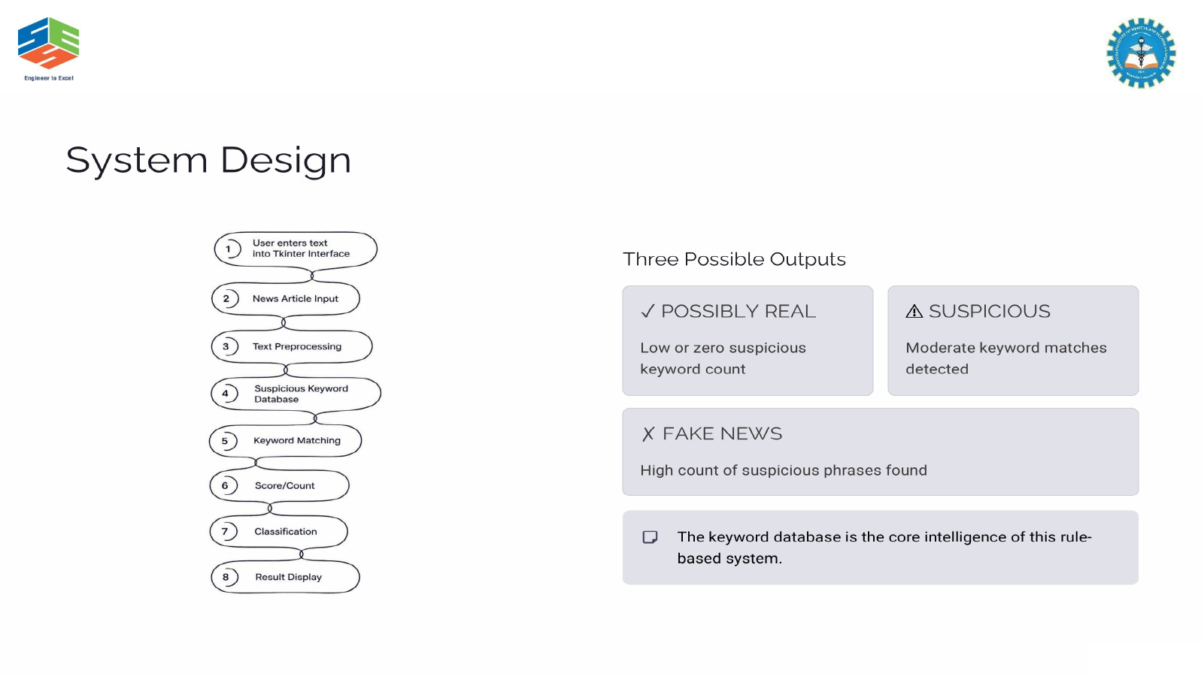
Fig. 3.1 System workflow and classification pipeline
Systems approach: the GUI supplies article text to the processing logic. The processing logic normalizes the text and checks the predefined keyword library. The matching loop produces a suspicious-keyword count, which is passed to the threshold classifier. The result and count are then presented through the GUI result labels.
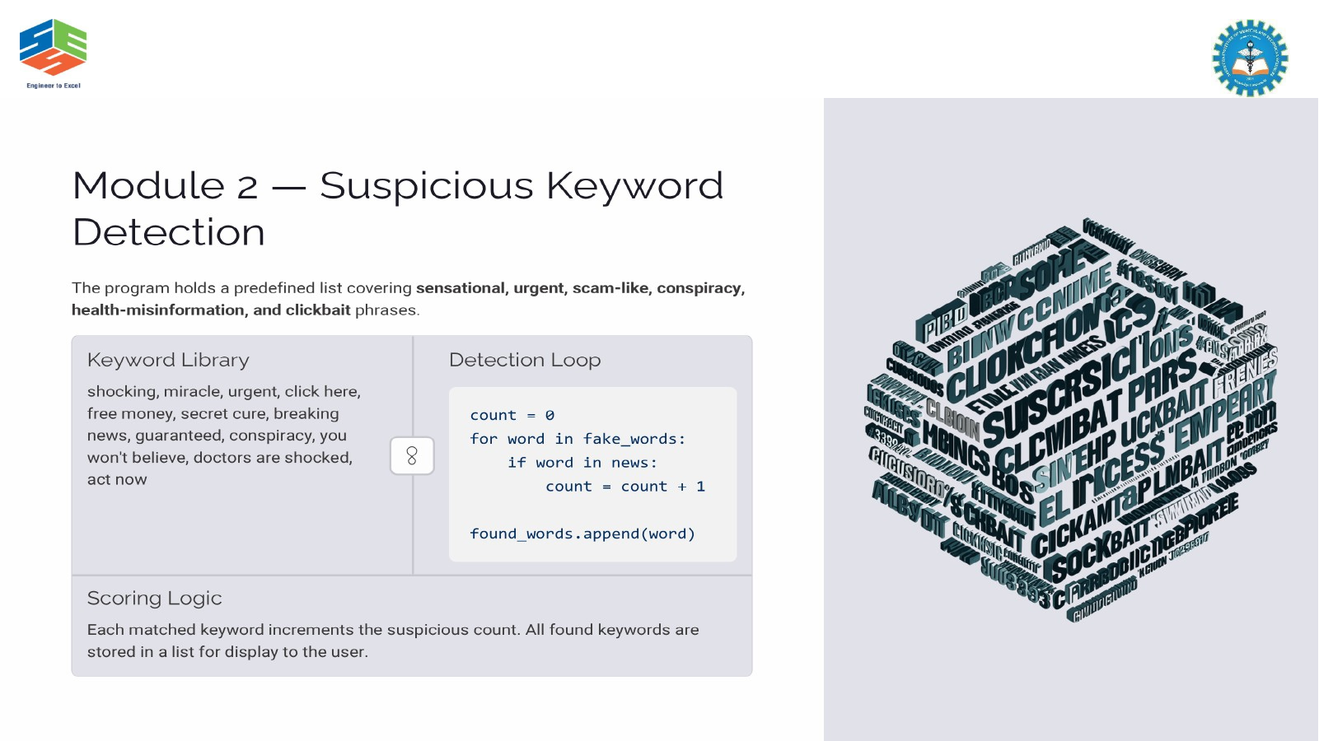
Fig. 3.2 Module 2 – Suspicious keyword detection

  - Trade-off Analysis

Table 3.6 – Trade-off Analysis
Design Decision | Alternative Considered | Benefit | Disadvantage | Final Decision & Justification
Rule-based keyword matching | Machine-learning classifier | Transparent, low-cost and easy to test | Cannot learn contextual patterns | Selected because the capstone requires an explainable local prototype.
Tkinter desktop GUI | Web/API application | No server or internet dependency | Local desktop only | Selected for simple deployment and demonstration.
Three threshold classes | Binary real/fake decision | Provides an intermediate warning level | Still heuristic | Selected because suspicious content may not justify a binary claim.

  - Sustainability, Ethics, Safety, Risk & Security

Table 3.7 – Sustainability, Ethics, Safety & Security
Domain | Consideration | Evidence Evaluated | Impact on Final Decision
Sustainability | Local execution and small computational footprint | No external server or continuous network service required | Supports a lightweight desktop prototype.
Ethics | Avoid presenting heuristic output as proven truth | Rule-based limitation and wording of outputs reviewed | Uses “POSSIBLY REAL”, “SUSPICIOUS” and “FAKE” labels as preliminary screening results.
Health & Safety | Prevent harmful over-reliance on automated output | No medical or emergency decision function is implemented | System is positioned as an informational screening aid.
Security | Avoid external data transmission | Processing is performed locally on entered text | Reduces dependency on third-party data services.

Risk Register

Table 3.8 – Risk Register
Risk | Likelihood | Severity | Risk Level | Mitigation | Residual Risk
False positive from suspicious wording | Medium | Medium | Medium | Explain rule-based nature; allow human verification | Low–Medium
False negative due to missing keyword | Medium | High | High | Expand and periodically review keyword library | Medium
Over-reliance on classification | Medium | High | High | Use preliminary wording and document limitations | Medium
Keyword list becomes outdated | Medium | Medium | Medium | Maintain and update rule library | Low–Medium

CHAPTER 4

IMPLEMENTATION, TESTING & RESULTS, PROJECT MANAGEMENT

  - Development Approach & Resources
The development followed a staged software workflow: requirements identification, GUI design, text-input handling, preprocessing, keyword matching, classification and testing. The implementation uses the standard Python Tkinter library and the scrolledtext widget, with no external database or web service. The supplied source code implements the analysis through the check_news() function and uses clear_news() for resetting the interface. Resources used were Python, Tkinter/scrolledtext, a desktop development environment, the supplied Python source file and representative news text inputs.
  - Hardware / Software / Fabrication Implementation & Modern Tools Used
Software implementation is the applicable engineering implementation for this project. The GUI creates a fixed-size desktop window, accepts multi-line text, provides CHECK NEWS and CLEAR controls, and presents the classification and suspicious-keyword count. The detection logic is implemented as explicit Python control flow and list-based keyword matching.

Table 4.1 – Tools and Resources
Tool / Software / Equipment | Purpose | Stage Used
Python | Core implementation language | All development
Tkinter | Desktop GUI construction | GUI design and implementation
ScrolledText | Multi-line news article input | Input module
Python list | Store suspicious keywords and phrases | Detection module
Conditional statements | Apply classification thresholds | Classification module
Desktop computer | Run and test the local application | Testing and demonstration

  - Test Plan & Verification

Table 4.2 – Test Plan and Verification
Requirement |  | Test Method |  | Acceptance Criterion
Functional verification |  | Representative input tests |  | Expected result and score
Specification | Required Value |  | Achieved Value |  | Status (Pass/Fail)
Input validation | Empty article |  | Validation message |  | Pass
Classification | 0 / 1–2 / ≥3 matches | Observed labels | Keyword count shown | Matches rule | Pass
  - Results:-

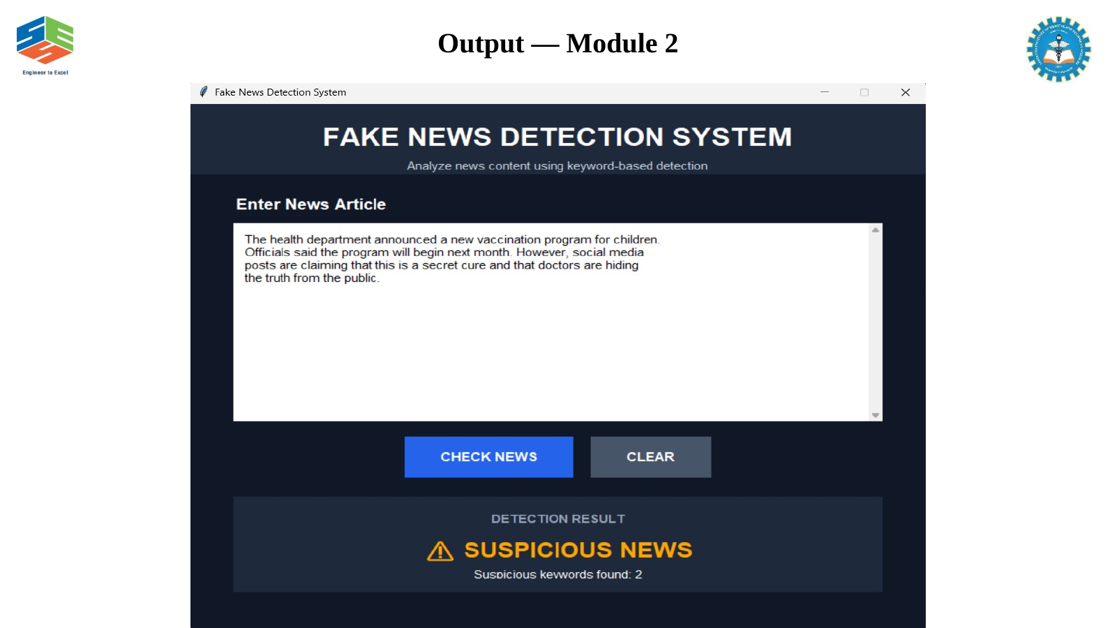
Fig. 4.2 Module 2 – Suspicious news output
Module 2 output: the supplied presentation demonstrates suspicious keyword detection and reports the number of detected indicators. The output shown in the presentation provides direct evidence that the matching stage feeds the classification stage.
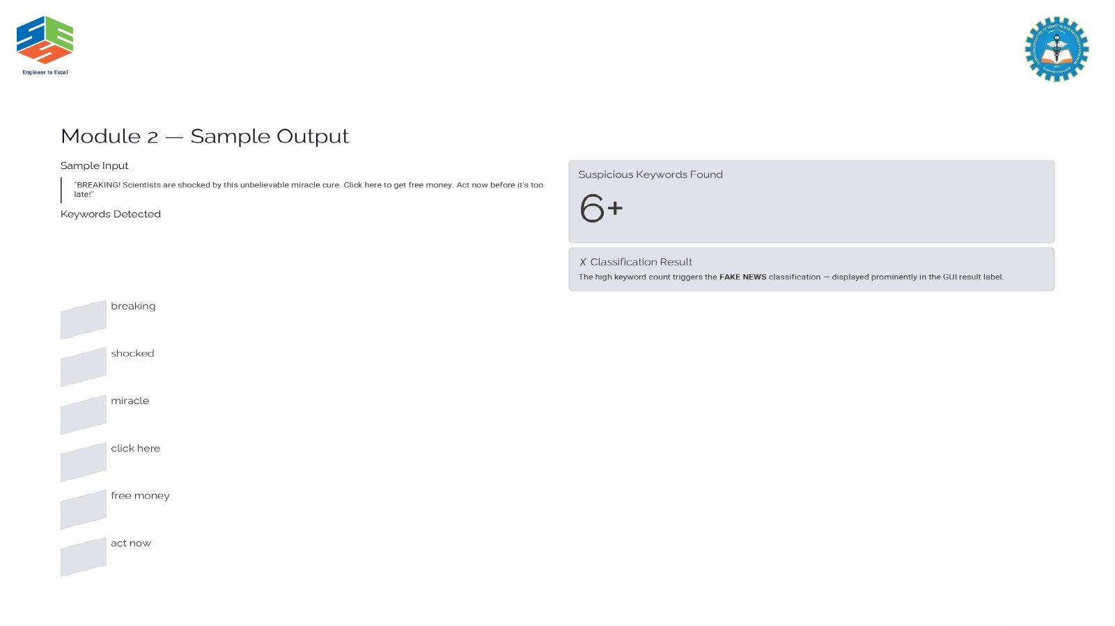
Fig. 4.3 Module 2 – Sample keyword detection output
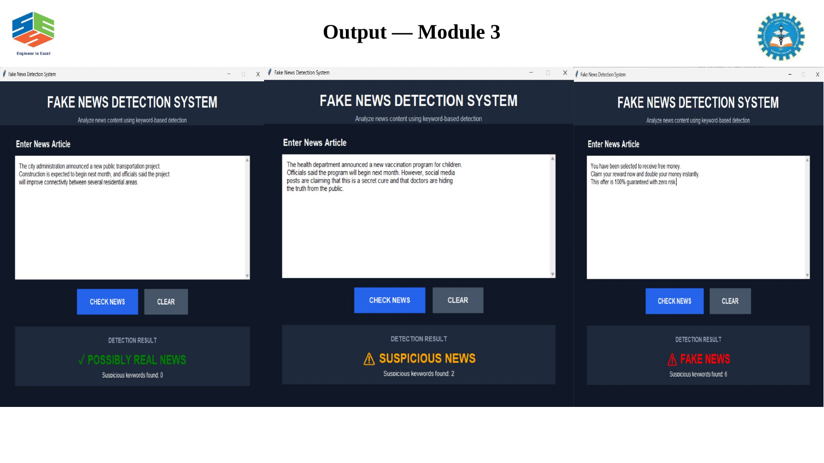
Fig. 4.4 Module 3 – Classification outputs
  - Data Analysis & Engineering Judgment
The observed outputs confirm that the system behaviour follows the implemented deterministic rules. The empty-input case is handled before keyword analysis. For non-empty input, the text is converted to lower case, each phrase is checked, the count is incremented for matches, and the count is mapped to the three result labels. This makes the result reproducible for the same input and keyword library. The main engineering limitation is that the score represents the presence of suspicious language rather than factual accuracy; therefore a high score should be interpreted as a warning for further verification.

  - Comparison with Existing Solutions & Achievement of Objectives

Table 4.3 – Objective Achievement
Objective | Evidence | Achievement (Fully/Partially/Not Achieved)
Design desktop GUI | Tkinter window, text box, CHECK NEWS and CLEAR buttons | Fully
Validate and preprocess input | Empty check plus strip/lower normalization | Fully
Detect suspicious content | Predefined keyword list and matching loop | Fully
Classify articles | 0 / 1–2 / ≥3 threshold logic | Fully
Test and demonstrate outputs | Presentation output screens for modules 1–3 | Fully
Provide factual verification | No external source or semantic verification | Partially – outside current scope
  - Strengths & Limitations
Strengths:
• Simple and transparent rule-based decision process.
• Fast local processing for pasted text.
• Easy-to-use Tkinter interface.
• Broad keyword categories including sensational, urgency, money, scam-like, health, conspiracy, authority, viral and clickbait language.
• Demonstrates core Python programming constructs in a real application.
Limitations:
• Keyword matching does not understand context or factual truth.
• Legitimate articles may contain suspicious words and produce false positives.
• New misinformation phrases may be missed until the keyword library is updated.
• No external fact-checking, source credibility analysis or machine-learning model is implemented.
  - Project Planning, Roles & Budget
Milestone timeline: Requirement analysis → GUI design → Module 1 input/preprocessing → Module 2 keyword detection → Module 3 classification → Testing and output validation → Documentation. The module responsibilities were distributed equally across the four team members as recorded in the Individual Contribution Statement.

Table 4.4 – Project Roles and Budget
Student | Assigned Responsibility | Actual Contribution
KEERTHAN M / PRADEEP / ASHWIN / BARANIDHARAN | Module 2 / Module 1 / Module 3 / Introduction and supporting presentation work | 25% each; 100% total
Item | Estimated Cost | Actual Cost
Python/Tkinter software and local development resources | No additional project cost | ₹0 additional software cost

CHAPTER 5

CONCLUSION, FUTURE WORK AND REFLECTION

  - The Fake News Detection System successfully demonstrates a lightweight, explainable approach to preliminary news screening using Python and Tkinter. The implemented workflow accepts article text, validates the input, normalizes it, checks a predefined suspicious-keyword library, counts matches and maps the count to three result categories. The presentation outputs confirm the intended GUI behaviour across the input, detection and classification stages. The system meets the stated prototype objectives, while its rule-based nature means that the result must not be treated as definitive factual verification.

  - Future work can extend the prototype without changing its basic workflow. The supplied project material identifies the use of labelled fake-news datasets, TF-IDF feature extraction, machine-learning models such as Random Forest or Logistic Regression, confidence scores, analysis-history storage, online fact-checking APIs, richer visualizations, multilingual support and sentiment analysis as possible enhancements. These additions would improve contextual coverage and reduce dependence on manually maintained keyword rules.

  - Professional Learning & Individual Reflection
New Knowledge Acquired:
• Practical Tkinter GUI development and event-driven interaction.
• String normalization, list-based rule storage and deterministic keyword matching.
• Threshold-based classification and test-oriented thinking.
• Understanding the difference between preliminary screening and factual verification.
Engineering & Professional Skills Developed:
• Problem decomposition into input, detection and classification stages.
• Translating requirements into testable software behaviour.
• Evaluating limitations and communicating engineering trade-offs.
• Team-based integration of module work and presentation evidence.
    - KEERTHAN M: The main engineering challenge in Module 2 was organizing a sufficiently broad suspicious-keyword library while keeping the matching logic simple and transparent. The selected list categories and counting loop provide a clear basis for the screening score.

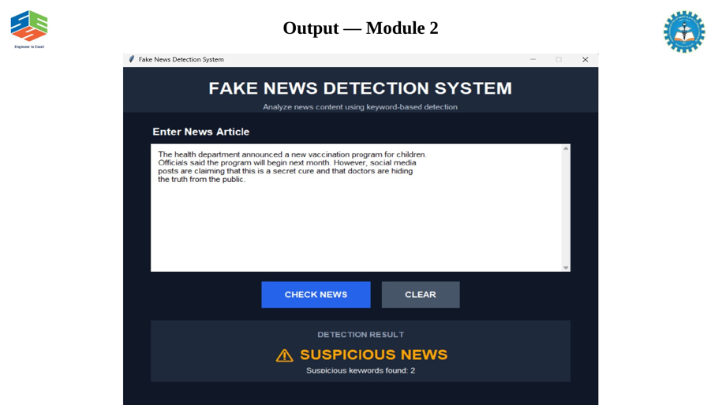
Module -2-Individual Contribution-Keerthan M

Fig 5.1-Module 2 output -individual contribution

Module 2 output: the supplied presentation demonstrates suspicious keyword detection and reports the number of detected indicators. The output shown in the presentation provides direct evidence that the matching stage feeds the classification stage.

REFERENCES

References are presented in a consistent IEEE-style form based on the literature and software references included in the supplied project presentation. The report does not introduce unsupported external research claims.
- [1] K. Sharma and A. Patel, “Deep learning approaches for misinformation detection in social media,” IEEE Transactions on Computer Society, vol. 11, no. 3, pp. 245–258, June 2024.
- [2] M. Chen, L. Wang, and R. Kumar, “Rule-based keyword detection for preliminary news classification,” in Proc. 2024 Int. Conf. Information Process. Manage., pp. 112–119, 2024.
- [3] J. Rodriguez, S. Lee, and P. Martinez, “Comparative analysis of machine learning models for fake news detection,” IEEE Access, vol. 12, pp. 78234–78251, 2024.
- [4] T. Nakamura, Y. Yamamoto, and Y. Tanaka, “Natural language processing techniques for detecting sensational language patterns,” in Proc. 2025 IEEE Int. Conf. Lang. Process., Tokyo, Japan, 2025.
- [5] A. Thompson, B. Wilson, and C. Davis, “GUI-based systems for real-time news verification,” J. Softw. Eng. Res. Dev., vol. 13, no. 2, pp. 89–104, May 2025.
- [6] S. Gupta, R. Verma, and N. Singh, “Hybrid approaches combining rule-based and machine learning methods for misinformation detection,” IEEE Intell. Syst., vol. 40, no. 4, pp. 156–168, July 2025.
- [7] E. Johnson, F. Brown, and G. White, “Future directions in automated fake news detection: From keyword matching to contextual understanding,” in Proc. 2026 IEEE Symp. Cyber Privacy, Sydney, NSW, 2026.

APPENDICES

Appendix A – Detailed Calculations
For each article, the suspicious score is the number of predefined phrases found in the normalized input. Classification rule: score = 0 → POSSIBLY REAL NEWS; score = 1 or 2 → SUSPICIOUS NEWS; score ≥ 3 → FAKE NEWS. The implementation increments the count once for each keyword/phrase whose text occurs in the article.

Appendix C – Source Code / Code Repository Information

The complete source file supplied for the project is “fake news detection system.py”. Selected module-specific excerpts are reproduced below to connect the implementation to the report modules.
# Module 1 – input acquisition and preprocessing
news = text_box.get("1.0", tk.END).strip().lower()
if news == "":
result_label.config(text="Please enter a news article!", fg="orange")
score_label.config(text="")
return
Module 1 code excerpt – input validation and normalization
# Module 2 – suspicious keyword matching
count = 0
found_words = []
for word in fake_words:
if word in news:
count = count + 1
found_words.append(word)
Module 2 code excerpt – keyword matching and counting
# Module 3 – classification
if count >= 3:
result_label.config(text="⚠ FAKE NEWS", fg="red")
elif count >= 1:
result_label.config(text="⚠ SUSPICIOUS NEWS", fg="orange")
else:
result_label.config(text="✓ POSSIBLY REAL NEWS", fg="green")
Module 3 code excerpt – threshold classification
Appendix E – Experimental / Raw Data
Appendix F – Ethics / Institutional Approval — Not applicable to this software-only academic prototype.
Representative verification categories: empty article → validation message; no suspicious phrase → POSSIBLY REAL NEWS; one or two suspicious phrases → SUSPICIOUS NEWS; three or more suspicious phrases → FAKE NEWS. The presentation supplies screenshots for these module outputs.
Appendix G – Project Meeting / Progress Records

Progress sequence documented from the supplied project material: requirements and introduction → methodology and system design → Module 1 → Module 2 → Module 3 → implementation and results → limitations, future scope and conclusion.
Appendix H – User / Industry Feedback — No external user or industry feedback was supplied for this prototype.
Appendix I – Publications / Patents / Competitions / Product Outcomes — None reported for this prototype.

Appendix J – Individual Contribution Evidence
The Individual Contribution Statement records equal contribution of 25% per team member. The project module allocation used for the report is Module 1 – PRADEEP; Module 2 – KEERTHAN M; Module 3 – ASHWIN; introduction and supporting presentation slides – BARANIDHARAN.

CAPSTONE PROJECT OUTCOME MAPPING SHEET

Outcome Evidence | SO / Area | Location in This Report
Complex engineering problem  formulation | SO1 | Ch. 1, Ch. 2
Engineering design under constraints | SO2 | Ch. 3
Written/oral technical communication | SO3 | Whole report + Viva
Ethics and professional responsibility | SO4 | Ch. 3 (3.7)
Teamwork and leadership | SO5 | Ch. 4 (4.8)
Experimentation, analysis, engineering  judgment | SO6 | Ch. 4 (4.3–4.6)
Independent acquisition of new  knowledge | SO7 | Ch. 5 (5.3)
Standards | SO2 | Ch. 3 (3.2)
Sustainability and  societal/environmental impact | SO2/SO4 | Ch. 3 (3.7)
Risk assessment and mitigation | SO2/SO4 | Ch. 3 (3.7)
Security considerations | Relevant SO | Ch. 3 (3.7)
Integrated/system-level engineering | SO1/SO2 | Ch. 3 (3.5)
Project planning and management | SO5 | Ch. 4 (4.8)
Individual contribution | SO1–SO7 | Contribution Statement + Ch. 4  (4.8)

